Q1:

Q2:

Q3: Finding Similar Items

1 - （1 – 0.6^5）^2 = 0.1495

Q4: Mining Data Stream

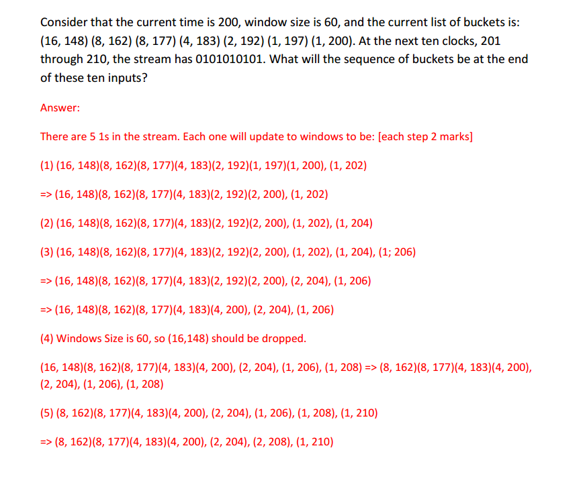

Q5: Recommender Systems

1. sim(u1, u2 ) = cos(r(u1), r(u2)) = $\frac{ 3*2 + (-1) * 3}{\sqrt{3^{2}+1} \sqrt{2^{2}+1+3^{2}} }$ ≈ 0.254

sim(u1, u3 ) = cos(r(u1), r(u3)) = $\frac{ 3*3 + (-1) * 1}{\sqrt{3^{2}+1} \sqrt{3^{2}+1+3^{2}} }$ ≈ 0.580

u3 has more similar taste to u1 since sim (u1, u3) > sim (u1, u2)

1. Item-Item CF

Find the similarity by pearson correlation coefficient

Avg(u1) = 1 avg(u2) = 1.33 avg(u3) = 2.33

sim (u1, u2) = $\frac{ 2*0.7+(-2)*1.7}{\sqrt{2^{2}+(-{2)}^{2}} \sqrt{{0.7}^{2}+{\left(-2.3\right)}^{2}+{1.7}^{2}} }$ ≈ -0.240

sim (u1, u3) = $\frac{ 2*0.67+\left(-2\right)*（-1.33）}{\sqrt{2^{2}+(-{2)}^{2}} \sqrt{{0.67}^{2}+{\left(-1.33\right)}^{2}+{0.67}^{2}} }$ ≈ 0.866

r(m2) = (-0.24 \* (-1)) / (-0.24+ 0.866) = 0.217

r(m3) = (0.866\*3) / (-0.24+0.866) = 2.35

I will recommend user with the movie 3

Answer: You can use either cosine similarity or Pearson correlation coefficient to compute  
the similarities between users. However, the conclusion should be that only m3 is  
recommended to u1.